

Historic Preservation Revolving Loan Fund
Guidelines & Pre-Application (Part A)

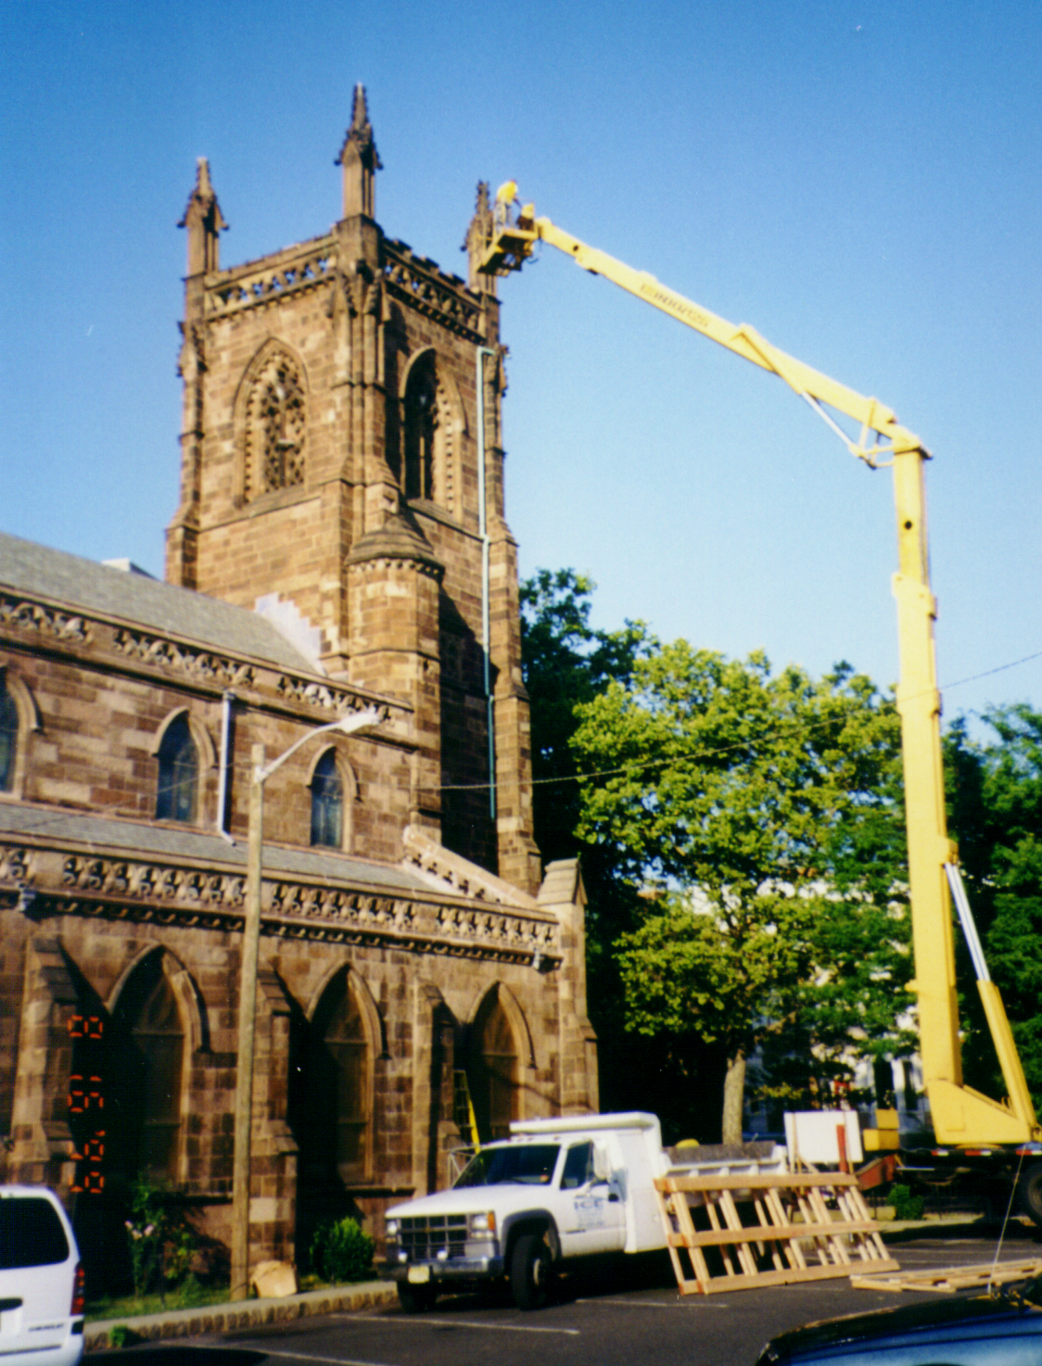

Historic Preservation Revolving Loan Fund

GUIDELINES
The New Jersey Historic Preservation Revolving Loan Fund (“Revolving Loan Fund”) was established by the Historic Preservation Revolving Loan Fund Act (P.L. 1991, c.41).
The $3 million Revolving Loan Fund has been financed from the $25 million Green Acres, Cultural Centers and Historic Preservation Bond Act of 1987.
The New Jersey Historic Trust, a body corporate and politic in the Department of Community Affairs and administrator of this loan fund, is a nonprofit historic preservation organization created to preserve and protect New Jersey’s historic resources. The Trust is governed by a fifteen-member board of trustees. Twelve members are private citizens appointed by the Governor, and three members serve ex-officio.
The guidelines that follow are a summary of the rules governing this program. For the complete text, see N.J.A.C. 7:4B.
Eligible Organizations
To be considered for a loan, applicants must be:
• nonprofit tax-exempt organizations; or
• agencies of county or municipal governments.
Eligible Properties
To be eligible for a loan, the property that is the subject of the project must be:
• individually listed in the National or State Register of Historic Places; or
• located within a historic district listed in the National or State Register of Historic Places. The property must be identified in the nomination of the district as contributing to the significance of the district; or
• included in a thematic listing of historic resources in the National or State Register of Historic Places; or
• certified by the Deputy State Historic Preservation Officer that the property, structure, facility or site is approved for listing, or meets the criteria for listing, in the State Register of Historic Places.
Loan Award Disbursement
The minimum loan amount to be accepted for review is $25,000.
The maximum loan amount to be accepted for review cannot exceed 15 percent of the available revolving loan fund balance as of the fiscal year (July 1) in which the application is submitted. Contact the Trust office for further information about the maximum loan amount for the current fiscal year.
Uses of Loan Funds
Loans will be made for the preservation, improvement, restoration, rehabilitation, and acquisition of historic properties as described in the following definitions:
“Preservation” means the act or process of applying measures to sustain the existing form, integrity, and material of a historic property.
“Improvement” means the act of upgrading the basic physical condition of a property in a manner consistent with the Standards for the Treatment of Historic Properties (Revised 1995) adopted by the Secretary of the United States Department of the Interior now in effect and as may subsequently be modified, changed or amended. This type of activity includes upgrading mechanical systems, providing appropriate barrier-free access for handicapped persons, and bringing a property into conformance with building codes.
“Restoration” is defined as the act or process of accurately depicting the form, features, and character of a property as it appeared at a particular period of time by means of the removal of features from other periods in its history and reconstruction of missing features from the restoration period.
“Rehabilitation” is defined as the act or process of making possible an efficient compatible use for a property through repair, alterations, and additions while preserving those portions of features which convey its historical, cultural, or architectural values.
“Acquisition” means the process of obtaining an interest in real property for the purpose of preserving or enhancing the historic, cultural or architectural significance of the property. Acquisition may include purchase of title, development rights, life estates, remainder interests, easements or other interests in real property which would result in the preservation of a historic property.
Match/Terms of Loan
Loan amounts will be for a maximum of 40 percent of project funding for all public entities and will not exceed 90 percent of project funding for nonprofit organizations.
The maximum interest rate to be levied on any loan will not exceed four (4) percent simple interest per annum.
The maximum term of a loan will not exceed 20 years. It is expected that the term for most loans will be ten years or less in duration.
Requirements for Projects
Loan recipients must sign a project agreement with the Trust.
All work funded through this program must be done in accordance with the Secretary of Interior’s Standards for the Treatment of Historic Properties (Revised 1995).
Criteria
The following criteria will be used to make loan award decisions:
• significance of the resource;
• physical condition of the property;
• plans for the preservation of the structure;
• compliance with the Secretary of the Interior’s Standards for the Treatment of Historic Properties (Revised 1995);
• administrative capability of the applicant to carry out the project;
• availability of applicant’s portion of project budget requirements;
• security available for the loan;
• financial plans for continued preservation of the project site; and
• degree and kind of public access.

Application Procedure
- Applications are available from the Trust and are accepted year-round. Applicants are urged to consult with Trust staff before submitting the “Part A Pre-application” (attached) for loan funds.
- Pre-applications are reviewed by the Trust’s Grants and Loans Committee.
- Eligible applicants with projects worthy of further consideration under the loan award criteria will then be asked to complete the “Part B Application,” which requests more detailed information and must be accompanied by a nonrefundable fee.
- Final decisions are made by the Board of Trustees upon the recommendation of the Committee. Review of applications and action on requests normally takes a minimum of three months.
- All loan awards must receive legislative approval before disbursement.

Historic Preservation Revolving Loan Fund
Pre-Application (Part A)
Mail original pre-application with attachments to:
New Jersey Historic Trust
P.O. Box 457
Trenton, NJ 08625-0457
Phone (609) 984-0473 - Fax (609) 984-7590
E-mail: njht@dca.state.nj.us - Web site: www.njht.org.

Hand Delivery only to: NJ Historic Trust, Department of Community Affairs, 101 South Broad Street, Trenton NJ 08608

Consultation with Trust staff is encouraged before submitting this pre-application. Incomplete pre-applications will be returned, so please read the form carefully. Complete all entries in the space provided or indicate not applicable (N/A).
Section One: Applicant
- Applicant organization name:
Address:
City:
State:
Zip:
Phone No.:
County:
NJ Legislative District:
- Contact Name:
Title:
Address:
City:
State:
Zip:
Phone No.:
Fax No.:
E-mail Address:

- The applicant is a (choose one):
❐ nonprofit incorporated organization
❐ county public agency
❐ municipal public agency
- Nonprofit applicants only:
  - Tax-exempt designation:
Federal tax-exempt no.:
  - Number of members:
  - Year founded:
  - Briefly describe the nonprofit’s mission and major programs.
- Municipal and county applicants only:
  - provide a total of annual line item expenditures for historic preservation activities (programmatic and capital expenditures) for the previous three fiscal years. Express each total as a percentage of the annual municipal or county budget.
year 1
year 2
year 3

Section Two: Property
- Name of project property:
Address:
Municipality:
County:
- Is the property leased?
        - If yes, what is the term of lease?
- Name and address of property owner:

- Identify all lien holders to the property:

- Historic Listing of property:
  - Give name of property as listed and date of listing (month and year):

  - Historic Registration (check all that apply)
  Listed individually on NJ or National Register of Historic Places
  contributes to a Historic District on NJ or National Register
  part of a thematic listing on NJ or National Register
❐ certified eligible for listing by the NJ Historic Preservation Office
❐ listed in a local historic district
- Is the project property located in a community designated as a:
❐ N.J. Main Street Community
❐ Certified Local Government
- Please give a brief summary of the historical importance of intended project structure or site

Section Three: Project and Loan Request
- Loan Request
  - Amount of loan request:
  - When are funds needed?
  - Term of loan requested:
  - Describe, in detail, your loan repayment strategy.

- Briefly describe the proposed project for which the loan is requested. Provide the estimated budget for the proposed project. Describe how Trust loan funds will be used.

- List sources and amounts of matching funds for project. Specify when matching funds will be available.

- Purpose of project (check all applicable):
❐ Preservation
❐ Improvement
  Restoration
  Rehabilitation
❐ Acquisition

- Summary of Project.
  - What is the current use for the property?
  - Is the property open to the public?
  - What is the proposed use at the completion of the proposed project?
  - Why is the project necessary and what are the desired results?

ATTACHMENTS:
  Nonprofits only: Copy of IRS organization designation letter
  Nonprofits only: Three most recent annual financial statements or IRS Form 990s
  Required for all applicants: A copy of the New Jersey or National Register of Historic Places nomination in which the site is included or a copy of the letter from the Deputy Historic Preservation Officer that certifies the property is eligible for listing in the NJ Register of Historic Places.
  Required for all applicants: A minimum of 5 recent color photographs of the project site

Applicant Assurance
Acting as a duly authorized officer of the applying organization, I submit this request for a revolving loan from the New Jersey Historic Trust.

Signature of Applicant:
Name (printed): Title:
Date:

Owner Assurance
As a duly authorized representative of the property owner, I acknowledge and endorse this request.
Signature of Property Owner:
Name (printed): Title:
Date:

